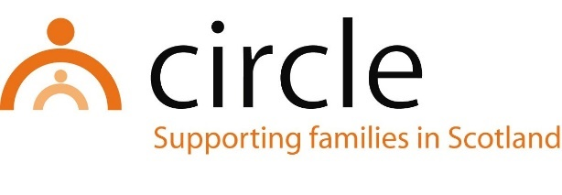

JOB DESCRIPTION
Family wellbeing practitioner
Haven Project

Number of Hours: Part Time (18 hours per week)

Salary Scale: Pro Rata to £26,870 - £31,144 per annum (SCP 12-17)

Accountability of post: The postholder will be line managed by and accountable to the Project Manager, Circle, for the performance of the tasks described below.

Main Purpose: To provide support to children and families to help improve the mental health and wellbeing of children, young people and promote their development and potential.

Location of post: Circle Haven Office, Craigroyston Primary School, Muirhouse Place West, Edinburgh, EH4 4PX (please note home working is normal currently)

MAIN TASKS & RESPONSIBILITIES:

- To work with parents/carers to promote a safer lifestyle for the family improving mental health and wellbeing
- To enable parents/carers to develop their parenting skills and relationships with their children
- To run individual, family and groupwork programmes
- To record, monitor and evaluate all work
- To attend supervision, team meetings and in-house training sessions as appropriate
- To contribute to the promotion and development of Circle’s work and services in Northwest Edinburgh
- To liaise with other agencies and work in partnership with them to meet the needs of the children and their families
- To work within Circle’s policies and procedures, most notably in areas of child protection, equal opportunities, anti-discriminatory practice, and user participation
- To attend Staff Development Days
With consultation, amendments may be made to your job description from time to time in relation to our changing needs and your own ability.

PERSON SPECIFICATION
Family wellbeing practitioner
Haven Project

QUALIFICATIONS
ESSENTIAL

- A professional qualification in social work, social care, education, or health

KNOWLEDGE & EXPERIENCE
ESSENTIAL

- Experience of planning and delivering programmes of activities for children and parents to improve family wellbeing and mental health
- Experience of working with children and their families in a community setting
- Experience of individual, family, and group-work
- Experience of working in partnership with other agencies
- Experience of working as part of a team
- Knowledge of child development and issues affecting vulnerable children and families
- Knowledge of the GIRFEC approach and the related Shanarri indicators
- An understanding of and commitment to equal opportunities, anti-discriminatory practice, and user participation

SKILLS & ABILITIES
ESSENTIAL

- Ability to communicate effectively with children and adults
- Ability to support social work students on placement with Circle
- Ability to record, monitor and evaluate work
- Ability to plan and prioritise work
- Ability to effect change in families
- Ability to work across professional boundaries
- Good assessment skills

