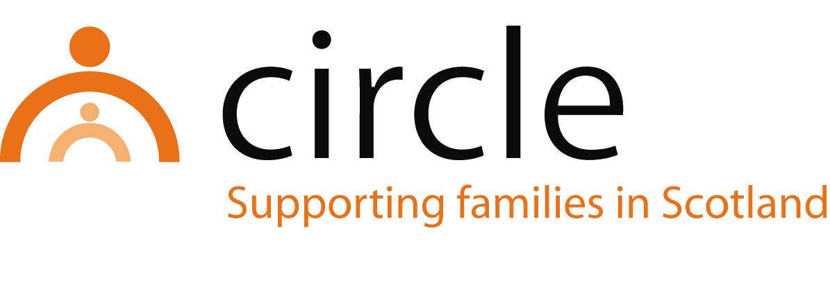

JOB DESCRIPTION
parent peer support Worker
Harbour Project

Number of hours: | Full-time (36 hours per week)
Salary scale: | £22,001 - £24,178 per annum (SCP 8-11)
Accountability of post: | The post holder will be line managed by the Family Inclusion  Co-ordinator and accountable to Circle’s Project Manager for the performance of the tasks described below
Purpose of post: | To provide peer support to parents across Edinburgh who are affected by substance use, and to work alongside the Family Inclusion Co-ordinator in the development and delivery of group opportunities for children and families affected by parental substance use
Location of post: | Circle Head Office, Edinburgh (hybrid working an option)

MAIN TASKS & RESPONSIBILITIES:

- To work closely with Family Outreach Workers in the Harbour Project to provide individual peer support to parents engaged with the service
- To support parents to take part in individual, family and group work programmes within Circle and more widely
- To be involved in the development, facilitation, and evaluation of groupwork and family activities, alongside parents, children and young people and the Family Inclusion Co-ordinator
- To record, monitor and evaluate all work
- To ensure family members’ views and experiences inform responses to, and meet the needs of, family members
- To liaise with other agencies and work in partnership with them to meet the needs of children and their families.
- To contribute to the promotion and development of Circle’s work and services in Edinburgh
- To attend supervision, team meetings and in-house training sessions as appropriate
- To work within Circle’s policies and procedures, most notably in areas of child protection, equal opportunities, anti-discriminatory practice and user participation
- To attend Staff Development Days

With consultation, amendments may be made to your job description from time to time in relation to our changing needs and your own ability.

PERSON SPECIFICATION
parent peer support Worker
Harbour Project

QUALIFICATIONS
ESSENTIAL
- A good general standard of education and literacy
- Working knowledge of Microsoft Office and other common IT software

KNOWLEDGE & EXPERIENCE
ESSENTIAL
- Lived experience of substance use and being a parent
- A minimum of one year living in recovery, free from all illicit substances and problematic drinking
- Experience of providing support to others (voluntary or paid)
- Knowledge of the harmful effects associated with substance use in relation to health, social welfare, housing, employability and personal relationships
- Knowledge of services and sources of help for people attempting to recover from substance use
- Knowledge of child development and wellbeing

DESIRABLE (from voluntary or paid work)
- Experience of planning and delivering group work
- Experience of working with children and their families in a community setting
- Experience of supporting individuals to address their needs
- Experience of working in partnership with other agencies
- Experience of working as part of a team
- Knowledge of issues affecting vulnerable families
- Knowledge of the GIRFEC approach, the related SHANARRI indicators, ‘Rights Respect Recovery’ and the Whole Family Approach Framework
- An understanding of and commitment to equal opportunities, anti-discriminatory practice and user participation

SKILLS & ABILITIES
ESSENTIAL
- Ability to communicate effectively with children and adults
- Ability to support social work students on placement with Circle
- Ability to record, monitor and evaluate work
- Ability to plan and prioritise work
- Ability to effect change in families
- Ability to work across professional boundaries
- Good assessment skills

