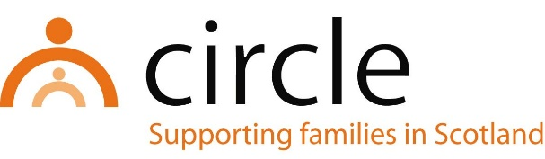

JOB DESCRIPTION
DEVELOPMENT MANAGER

Number of Hours: | Part-time (18 or 27 hours per week)
Salary Scale: | Pro-rata to £31,606 - £35,166 per annum (SCP 21 - 25)
Accountability of post: | The post holder will be line managed by and accountable to the Chief Executive of Circle for the performance of the tasks described below.
Main purpose: | The Development Manager will be responsible for overseeing participation strategy, beneficiary participation and consultation, practitioner research, disseminating research findings, and contributing to service development. To lead on Circle’s commitment to Keeping the Promise.
Location of post: | Head Office, 18 West Pilton Park, Edinburgh EH4 4EJ with hybrid working

MAIN TASKS & RESPONSIBILITIES:
- To further develop our participation strategy and to ensure that children’s, young people’s and families’ views are understood and integrated into service delivery, policy development and the management and governance of Circle
- Lead on the refresh and further development of our Whole Family Support Practice Principles to fully incorporate the lived experiences of families
- To support the publication/dissemination of internally generated research
- To develop briefings and training resources using internally generated research
- To support implementation of improvements to our planning, recording, outcomes and evaluation systems in a way that embeds the views of families.
- To lead on Circle’s commitment to keep The Promise
- To identify evidence, including level of need and support opportunities, to develop innovative practice and services
- To participate in partnerships relevant to the role to promote participation, generate and share evidence and to support innovation
- To work in partnership with the management team to identify opportunities to generate additional income for the organisation and support funding applications
- To attend Staff Development Days

With consultation, amendments may be made to your job description from time to time in relation to our changing needs and your own ability.

PERSON SPECIFICATION
DEVELOPMENT MANAGER

QUALIFICATIONS
ESSENTIAL
- A professional qualification in social work, social care, health or education

KNOWLEDGE & EXPERIENCE
ESSENTIAL
- Experience of leadership including personal development and objective setting
- An understanding of the current issues facing vulnerable children and families
- Experience of leading participation of beneficiaries in service development.
- A good understanding of policy in a children and families environment including UNCRC and The Promise.
- A knowledge of the key issues affecting service provision in the voluntary sector, particularly in respect of family support
- Experience of research and dissemination of findings
- Excellent written, communication and organisational skills
- Ability to effectively promote the work of Circle within and outside the organisation
- Ability to manage a demanding workload and meet deadlines
- Ability to develop good working relationships with colleagues, the Board of Trustees and external stakeholders
- Ability to manage and prioritise own workload
- Strategic development skills

ATTITUDES
ESSENTIAL
- Commitment to the values of Circle
- Commitment to anti-oppressive and anti-discriminatory practice
- Commitment to continuing professional learning and development

