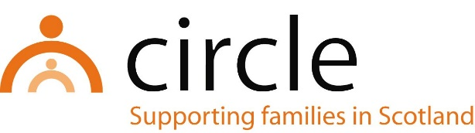

JOB DESCRIPTION
Head of Operations

Number of Hours: | Full-time (36 hours per week)
Salary Scale: | £42,264 - £45,252 per annum (SCP 33 - 36)
Accountability of post: | The post holder will be line managed by and accountable to the Chief Executive of Circle for the performance of the tasks described below.
Main purpose: | The Head of Operations will provide day to day operational management of service delivery, and work with the Chief Executive to provide strategic direction and development.
Location of post: | Head Office, Edinburgh  (own car and driving licence essential)

This is a senior role within the management team at Circle. The successful candidate will play a key role working with the Chief Executive and management team to drive the strategic direction, financial wellbeing and operational effectiveness of the organisation. The role will require an experienced, pro-active, and dynamic individual who can drive change and develop new and more effective ways for the charity to achieve our vision for all children to be safe, happy, healthy, and nurtured within a stable family which supports them to achieve their potential.

MAIN TASKS AND RESPONSIBILITIES:

- To provide operational and strategic leadership, direction, support and supervision to the project management team, enabling them to contribute effectively to the work of Circle

- To work with the Chief Executive and project management team on business planning and strategic and operational development of Circle’s services across a range of localities

- To take a lead on safeguarding policy and practice across the organisation

- To ensure staff comply with Circle’s Professional Practice Policies and Procedures

- To work with the Chief Executive, Finance Manager and management team to maintain and improve the overall financial position of the organisation and drive business development.

- To ensure that staff receive appropriate induction, supervision, appraisals, training and development to carry out their duties, and to promote staff wellbeing

- To promote high quality and effective delivery of all Circle’s services locally and nationally, and lead on practice development

- To maintain and develop excellence and innovation in service delivery, promoting participation of families in service design and development

- To monitor service activity and outcomes and lead on the preparation of reports and evaluations for a range of external stakeholders

- To take a lead on contracts, tenders, grants processes and other funding opportunities

- To work closely with the management team to develop and sustain relationships with a range of funders, partners, policymakers and other external stakeholders

- To positively promote the work of Circle and raise Circle’s profile through participating in a range of forums including Third Sector Interfaces, partnerships, working groups and consultations

- To promote and further develop a learning culture that focuses on continuous improvement and development across the organisation

- To deputise for the Chief Executive

With consultation, amendments may be made to your job description from time to time in relation to our changing needs and your own ability.

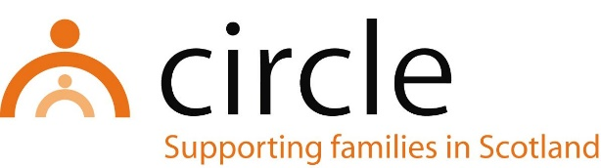

PERSON SPECIFICATION
Head of Operations

ESSENTIAL
- A professional qualification in social work, social care or health and a strong track record of taking responsibility for safeguarding practice across children and adult services
- A minimum three years’ experience of managing staff and services in a social care setting
- Experience of practice leadership including motivation, supervision, appraisals, personal development and objective setting
- Experience of budgeting and financial management
- Experience of leading on funding applications, tenders, grants processes and contract management
- A knowledge of practice and policy in areas such as community justice, recovery, early years, poverty, and inclusion
- Experience of service design and practice development

DESIRABLE
- A recognised qualification in management/leadership in Health and Social Care.
- A knowledge of the key challenges facing the voluntary sector
- A background in promoting children's rights including knowledge of UNCRC and GIRFEC
- Experience of working in partnerships
- Experience of promoting participation of children and families in design and development of services

SKILLS, ABILITIES AND APTITUDES
- Able to effectively plan, develop and lead on the delivery and evaluation of high quality services
- Able to proactively and effectively promote the work of Circle within and outside the organisation
- Able to manage a demanding workload and meet deadlines
- Able to develop good working relationships with colleagues, the Board and external stakeholders

ATTITUDES
- Commitment to Circle’s values and the practice principles
- Commitment to anti-oppressive, anti-discriminatory and inclusive practice
- Commitment to continuing professional learning and development
- Commitment to continuous improvement

