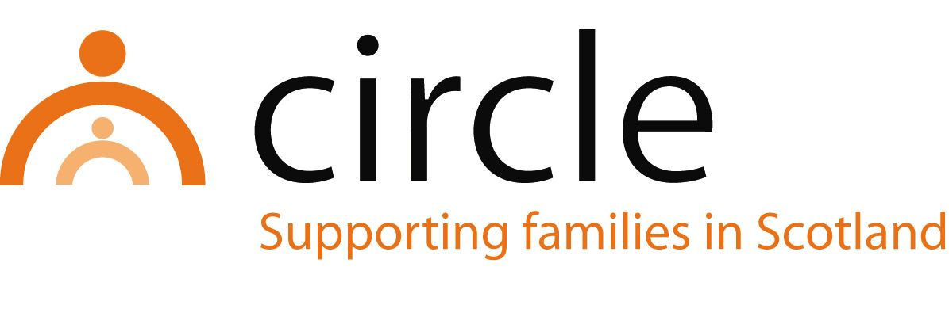

JOB DESCRIPTION
Family Outreach Worker – East Lothian

Number of Hours: Full time (36 hours per week)

Salary Scale: £25,659 - £29,740 per annum

Accountability of posts: The postholder will be line managed by and accountable to the Project Manager of Circle for the performance of the tasks described below.

Main purpose: To provide support to children and families affected by parental drug and/or alcohol use to minimise the impact on the children.

Location of posts: East Lothian Social Work Centre, Macmerry
(Own car and driving licence essential)

MAIN TASKS AND RESPONSIBILITIES:
- To work with parents/carers to promote a safer lifestyle for the family.
- To enable parents/carers to develop their parenting capacity and relationships with their children.
- To run individual, family and group work programmes.
- To record, monitor and evaluate all work.
- To attend supervision, team meetings and training as appropriate.
- To liaise with other agencies and work in partnership with them to meet the needs of children and their families.
- When required, to support, supervise and train sessional workers, students and volunteers.
- To contribute to the promotion and development of Circle’s work and services in East Lothian.
- To work within Circle’s policies and procedures, most notably in areas of child protection, equal opportunities, anti-discriminatory practice and user participation.

With consultation, amendments may be made to your job description from time to time in relation to our changing needs and your own ability.

PERSON SPECIFICATION
Family Outreach Worker – East Lothian

QUALIFICATIONS
ESSENTIAL
- A professional qualification in social work, social care, education or health

KNOWLEDGE / EXPERIENCE
ESSENTIAL
- Experience of working with families in a supportive way
- Knowledge of a range of interventions for supporting children and families
- Experience of working in partnership with other agencies
- Experience of working as part of a team
- Knowledge of child development and issues affecting vulnerable children and families
- Knowledge of the GIRFEC approach and the related Shanarri Indicators
- An understanding of and commitment to equal opportunities, anti-discriminatory practice and user participation

SKILLS/ABILITIES
ESSENTIAL
- Good assessment skills
- Ability to communicate effectively with children and adults
- Ability to support social work students on placement with Circle
- Ability to record, monitor and evaluate work
- Ability to plan and prioritise work
- Ability to effect change in families
- Ability to work across professional boundaries

