Circle Participation Strategy – Management Team SWOT analysis
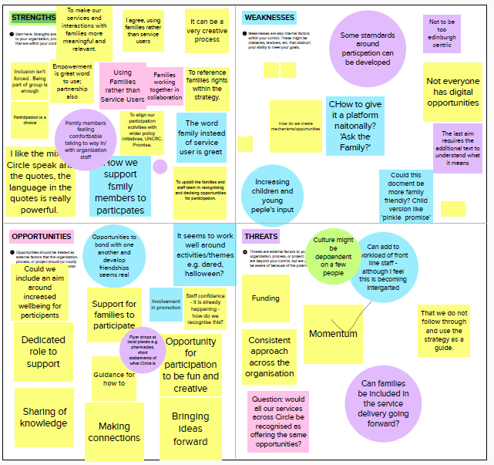
5-11-2021

Strengths
- Using families rather than service users
- Inclusion isn't forced . Being part of group is enough
- "Empowerment is great word to use; partnership also"
- Families working together in collaboration
- Using Families rather than Service Users
- Participation is a choice
- Family members feeling comfortable talking to/with organisation staff as a “way in”
- To align our participation activities with wider policy initiatives, UNCRC. Promise.
- I like the mix of Circle speak and the quotes, the language in the quotes is really powerful.
- The word family instead of service user is great
- How we support family members to participate
- To upskill the families and staff team in recognising and devising opportunities for participation.
- It can be a very creative process
Weaknesses
- Some standards around participation to be developed
- Not everyone has digital opportunities
- Not to be too Edinburgh centric
- How do we create mechanisms/opportunities?
- How to give it a platform nationally? 'Ask the Family?'
- The last aim requires the additional text to understand what it means
- Could this document be more family friendly? Child version like 'pinkie promise'
- Increasing children and young people’s input
Opportunities
- Opportunities to bond with one another and develop friendships seems real
- Could we include an aim around increased wellbeing for participants?
- It seems to work well around activities/themes e.g. dared, Halloween?
- Support for families to participate
- Staff confidence - it is already happening - how do we recognise this?
- Involvement in promotion
- Dedicated role to support
- Opportunity for participation to be fun and creative
- Flyer drops at local places e.g. pharmacies, short statements of what Circle is
- Guidance for how to “do” participatory activity
- Sharing of knowledge
- Making connections
- Bringing ideas forward

Threats
- Culture might be dependent on a few people
- Funding
- Can add to workload of frontline staff - although I feel this is becoming integrated
- Momentum
- That we do not follow through and use the strategy as a guide.
- Consistent approach across the organisation
- Can families be included in the service delivery going forward?
- Question: would all our services across Circle be recognised as offering the same opportunities?

Points made from general discussion
Is there anything about supporting families to take part, like childcare or quiet space? This could help people with an ongoing commitment to participation.
There was a football thing put on once and I hate football. But I went along, didn’t play, but still felt included in it. I wasn’t participating but I was still part of it.
We could be more specific in how we meet the aims, how we create the opportunities and what the mechanisms are.
With the rise of Zoom being the new norm for doing things in groups, it kind of secludes some people because not everyone has the confidence to voice their opinion over video call.
The opportunities that I’ve had with Circle have been fantastic. The doors that it opens have seemed endless. It’s quite nice to have something to look forward to.
When I first got involved with Circle it looked like there was only a few options there, but the more you are involved, the more doors opened and it kind of built on top of itself.
The support network that you develop is crucial. The people I have met through Circle will be friends for life, let’s be honest, you don’t often find that with groups. Sometimes you get people going into wee cliques within the group and it’s quite easy to just label someone. With Circle I have never felt that.
I think that speaks volumes because people feel safe and comfortable and that’s really, really important.
Some people might want to see a completely different version of this, something like the “pinkie promise”. It’s how we bring that alive really.
Even with children’s groups that are happening, it can look like just a set of fun activities, but there is a real kind of bonding taking place. Like children sharing some of their challenges with each other and it is quite a dynamic process. Sometimes what they (children) take away from it is , it’s from the side really, it’s stuff that we may not have thought of which is amazing.
I would say that all the activities that Circle have created (in Edinburgh) that the North of Edinburgh feels more connected now. Through participation, I now know people in the area that I didn’t know before.
It gives you the confidence to bring through some of your ideas, bring your ideas to the picture as well you know. A threat to that is sometimes you can make all those plans and just through lack of communication it can always fall apart last minute which can be quite disheartening but that’s life I suppose.
It might be good for people (new families) to have some sort of mentor so they’ve got someone there, not the workers of the project, but somebody there that has been through it that knows certain things and can support people just to a certain extent, because you don’t want to scare people away as well. (this is in the context of supporting people to participate in activities)
Is there a risk about it being quite a closed group at the moment (Full Circle Group)
It really helps me as a manager to reflect together with families.
I think there is an opportunity there to start to promote the skills and the confidence with staff and the families that we work with. They (staff) are doing that on a daily basis, but it’s about having the confidence to actually name it. I think a lot of this is being done but we’re not very good at saying it and putting it into that (participation) context.
It’s about how we recognise it and put a bit more structure around it.
Wondering what we can do maybe throughout the year so that we can keep momentum….but also presence. We have chapters in national guidance which has come from families, come from the research (“Ask the Family”). I think we are getting more and more recognised not just as Circle but from the families and the support we provide. Is there more that we could do? That maybe costs a bit more money as well though.
I’ve lived in the North of Edinburgh for 20 years and I only found out about Circle a couple of years ago. When I went to set up a just giving page for an abseil, it didn’t recognise Circle as a charity, for all tha good that Circle does, how come they are not recognised?
I found that too when I was looking into doing a sky dive. I could not find Circle anywhere. That was quite disheartening because if I’m going to do it, I want to do it for something that means something to me.
We tend to all (services) promote things locally, like attending local events and also dropping leaflets as well. Word of mouth is probably the most important thing. It says something about branding though doesn’t it.
I thought that after all of this (the strategy) was sorted out, there could be like pamphlets that we (Full Circle group) could hand out ourselves. It’s like you’re not forcing people to be involved but you’re giving them the opportunity to know that the charity is actually there.
It’s just better signposting basically. I tell people about Circle and people ask “what do they do?” and it’s like, I’m on the website and you do so much….so it’s just improved signposting.
If it’s all written down, and you hand people a leaflet, they might have questions that they want to ask you and you could always say to them that you have been involved.
Maybe the values work would be a good way of getting “what Circle is” into some short statements that could be distributed.
Is there an organisation that does this really well? (promotion) – No, not one.
Like Edinburgh arts centre puts on so many things for the community for people that are struggling, and I never even knew it was there and I had lived there for about 15 years. It is by word of mouth that people find out about these things.
We need to set the benchmark and show people how it’s done!
I think it was a family member that told me about Circle. It wasn’t someone random it was like a cousin that said, “you need to contact these guys” I’ll always be grateful to him for that.
It was a lady in a primary school that got me signposted to Circle.
The final aim in strategy (increased signposting) it doesn’t stand alone, I found it a wee bit difficult to understand. I had to read it a few times and was just wondering if there was a simpler language that says the same thing? When you read the bit about why it was added, that explains it to me but the aim itself doesn’t quite do it on its own.
How do we engage other people around the organisation in this?...or is that a separate conversation? You can imagine the board will read this and say that it’s brilliant and lovely, but is it something that we do a board presentation and then that’s it, it’s there for a year.
It definitely needs some form of launch and some publicity around it. Doing it alongside the values work…it’s not like a “re-launch” or anything but more like a public stake in the ground on this is the direction we are going in and this is what we are going to do.
Perhaps a thread through the newsletter? Perhaps in every newsletter there is participation there so there is an outlet?
There will be a specific section on the restructured website for participation which will allow for updates as the work happens.
Even get one of us (Full Circle group) to say something at the end of it? Like a wee video or something?
People have been really good at coming forward and doing these kind of things for us. I do feel a bit protective over people, especially children, in making them public, but as long as it is a choice and an informed choice, then it’s ok.
When we do launch, we could do a survey monkey or something so that we can reflect and review what the public opinion is? It’s all good us saying all of this, but to the outside world it might reflect completely different to what we’re saying.
The process of bringing families together from different areas needs to be sensitive to any existing/previous relationships between people. But it would be good to make connections between people from different local authorities too.
Can we bring general feedback gathered from families into this particular process so that we can confidently say that all services have this approach inherent to them.
(asking Full Circle group) How can we engage with/consult better with families? All I can say is measure the impact. Don’t just measure the amount of participation. Measure the impact on that family. They might have just participated in 1 thing, but the impact could be huge, it could be massive, it could completely change their life. So rather than asking, “How did you find participating in this?” ask “What impact did that have?” Doing that might make them think that participating in that 1 little activity had a huge impact so they might be chomping at the bit to take part in every opportunity.
There is a barrier for people coming into Circle because they don’t know what they are coming into. It would be good to have someone already involved to let them know how you operate. It’s not about money. We are willing to offer our experiences to help Circle to get more people in.

Comments from Chat Box
From Mark Kennedy: The aims are comprehensive and cover the benefits well.
From Mark Kennedy: Could we include an aim around increased wellbeing for participants
From Mark Kennedy: Threat: That we do not follow through and use the strategy as a guide.
From Mark Kennedy: Opportunity. To make our services and interactions with families more meaningful and relevant.
From Mark Kennedy: Opportunity: To align our participation activities with wider policy initiatives, UNCRC. Promise.
From Justajamie : the best experience is life experience.
From Mark Kennedy: Opportunity: To upskill the families and staff team in recognising and devising opportunities for participation.
From Justajamie : the passion of all members both staff and families is immense
From Annie Williamson : I think like we've said, all our services have this approach inherent in them, but we don't have a simple way of saying it within each service or across the whole organisation. This exercise has brought it to life, and to have this evidence base is fantastic. Can we build in families' views from across all our services? to ensure the consistency?
From Justajamie : it's a shame it has that feel as I think it needs to be inclusive across Scotland and I just wonder how we make that happen
From Justajamie : it's a circle we are all in 🙂
From Darren Pike (Circle) : I think looking at Comms - perhaps we could have a family takeover day/period - input into social media, newsletter etc. Johnnie can have a video done. Brian jumping off the plane. Jamie championing DARED
From Annie Williamson : Good idea Darren
From Justajamie : absolutely, empowerment
From Annie Williamson : Impact over the long-term as well would be good to measure

